

FACULTY: OF INFORMATION COMMUNICATION TECHNOLOGY

Title: Group Project
Lecturer/Supervisor: Santigie Foday Kamara
Class: BSEM 1102F
Semester/Year: SEMESTER 2 of 4
Date: 21/06/2026
STUDENT NAME | ID NUMBER | SIGNATURE
Solomon Massein Kanu | 905005767
Alpha Sesay | 905006158
Joseph Vandy | 905005916

Academic Honesty Policy Statement
I/We, hereby attest that contents of this attachment are my own work. Referenced works, articles, art, programs, papers or parts thereof are acknowledged at the end of this paper. This includes data excerpted from CD-ROMs, the Internet, other private networks, and other people’s disk of the computer system.

LECTURER’S COMMMENTS/GRADE: | for office use only upon receive  Remark  DATE :  TIME :  RECEIVER’S NAME :

Table of Contents
Introduction and Project Justification 2
System Architecture Design 3
Diagram of the Architecture 3
Component Interaction and Data Flow 3
Project Plan (Gantt Chart & Network Topology) 5
Gantt Chart 5
Network Topology 6
Prototype Development & Application Flow (UI/UX Design) 9
1. Splash Screen 9
2. Login Page 9
3. Create Account Page 10
4. OTP Page 10
5. Home Page 10
6. Order Page 10
7. Driver Matching Screen 11
8. Receipt Screen 11
9. Profile Screen 11
Conclusion 13

Introduction and Project Justification
Our team chose to design a Smart Ride-Hailing System specifically tailored to address the pressing urban mobility challenges in Sierra Leone. The country’s current transportation landscape relies heavily on informal networks, which frequently suffer from unpredictable, non-transparent pricing and significant safety vulnerabilities particularly for women, children, and the elderly.
By structuring this platform as a Digital Public Good, we aim to formalize and digitize the local transport sector. Our project aligns directly with UN Sustainable Development Goal 11 (Sustainable Cities and Communities) through several key mechanisms:
- Optimizing Urban Mobility: Streamlining the ride-matching process dramatically reduces passenger wait times and provides a dependable alternative to informal transit.
- Mitigating Congestion and Emissions: Smart routing minimizes unnecessary cruising and fuel waste, paving the way for future eco-friendly ride-sharing features.
- Elevating Safety Standards: Incorporating live GPS tracking, mandatory driver verification, and a transparent, mutual rating system establishes much-needed accountability.
- Driving Economic Opportunity: The platform offers local drivers formal, flexible earning potential, supporting decent work environments and localized economic growth.
- Bridging the Digital Divide: By blending accessible smartphone tech with mobile money ecosystems, we promote financial and technological inclusion for everyday citizens.
Ultimately, this system transitions a fractured transit model into an organized, safe, and reliable public utility.

System Architecture Design
To ensure high availability, security, and smooth maintenance, we opted for a classic Layered Architecture. This design decouples the user-facing interfaces from the core business logic and underlying data structures, making the entire ecosystem highly scalable as user demand grows.

Diagram of the Architecture

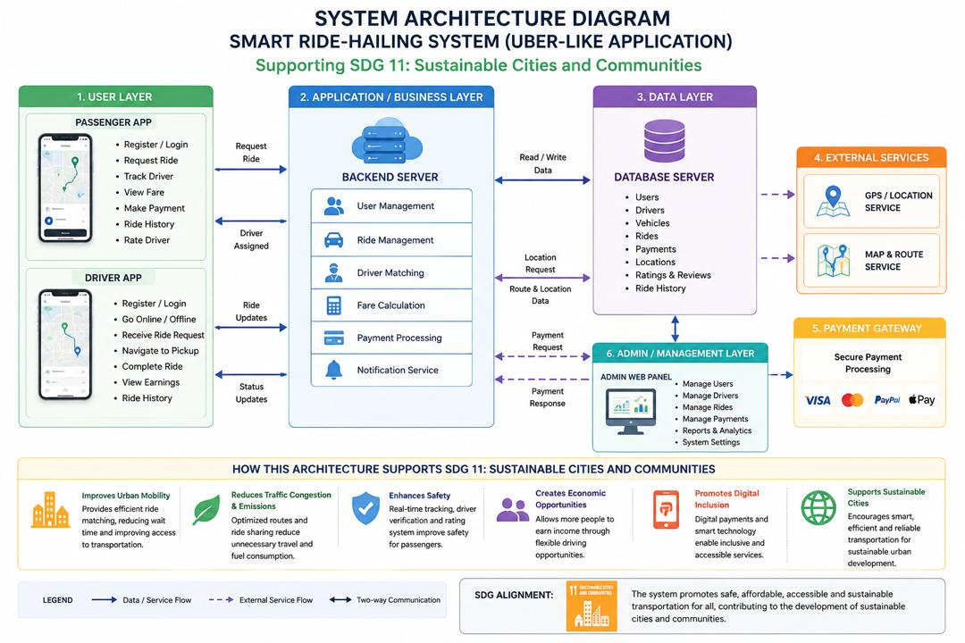

Component Interaction and Data Flow
To understand how these layers cooperate in a real-world scenario, we can trace the data flow of a standard "Book a Ride" use case:
- Initiating the Request (User Business Layer): The process begins when a passenger inputs their destination into the app. This triggers a secure REST API request sent directly to the Backend Server.
- Mapping and Fare Calculation (Business Layer External Services): The Backend Server contacts external mapping engines (such as Google Maps API) to compute the fastest route, total mileage, and estimated travel time. Concurrently, it references the user's live GPS coordinates to pin the exact pickup location. The internal Fare Calculation module then processes this data to generate a dynamic price.
- Algorithmic Driver Matching (Business Layer Data Layer): The backend queries the database for available drivers within a close radius. It filters for drivers who are currently marked "Online" and possess strong safety ratings, sending a push notification to the top three closest matches.
- Acceptance and Real-Time Tracking (Business Layer User Layer): Once a driver accepts the trip, the system establishes a two-way WebSocket connection. This allows the driver's live location to stream seamlessly to the passenger's screen, and vice versa, keeping arrival times accurate.
- Trip Completion and Checkout (User Business Payment Gateway): Upon reaching the destination, the driver marks the trip as complete. The passenger's chosen mobile money wallet (e.g., Orange Money ) is charged via a secure external Payment Gateway. Once the gateway confirms the transaction, it returns a success token to our backend.
- Administrative Oversight (Business Layer Admin Layer): The Admin Web Panel monitors the transaction in real-time. Admins can audit payment logs, reconcile outstanding balances, and handle driver payouts, ensuring absolute financial integrity.

Project Plan (Gantt Chart & Network Topology)
To guarantee the timely launch of this project, we built a rigorous schedule to map out task dependencies. By pairing a traditional Gantt Chart with a Project Management Network Diagram, we are able to closely track our progress and pinpoint our operational bottlenecks.

Gantt Chart
Project Phase & Core Tasks | Weeks | W1 | W2 | W3 | W4 | W5 | W6 | W7 | W8 | W9 | W10
Phase 1: Research & UI/UX Design  (Tasks A & B: Planning & Figma Specs) | W1 - W3 | 🟩 | 🟩 | 🟩
Phase 2: Core Engineering & Data  (Tasks C & D: Architecture & MySQL) | W3 - W4 |  |  | 🟩 | 🟩
Phase 3: Integration & Frontend Build  (Tasks E, F & G: Backend, App, APIs) | W5 - W7 |  |  |  |  | 🟩 | 🟩 | 🟩
Phase 4: Validation & Deployment  (Tasks H, I, J & K: QA, Admin Web, Release) | W8 - W10 |  |  |  |  |  |  |  | 🟩 | 🟩 | 🟩

Network Topology
In project management workflow design, we implement an Activity-on-Node (AON) structure, which maps explicit task dependencies as connected vectors. This topology serves a critical purpose: mathematically identifying our project's Critical Path, which determines our earliest possible date of completion.
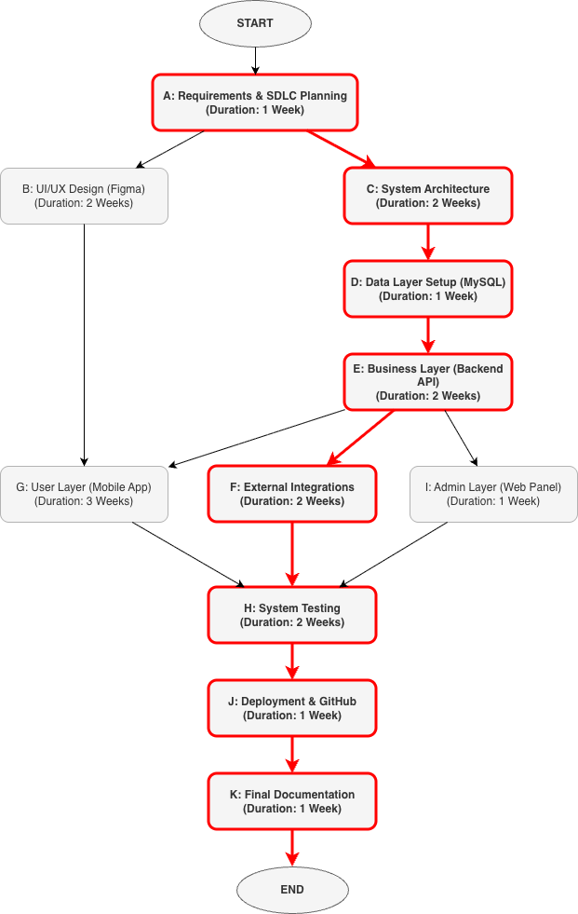

A. Dependency Mapping (Nodes & Edges)
- Node A (Requirements): The baseline milestone. No work can begin until parameters are scoped.
- Nodes B (UI/UX) & C (Architecture): These execute concurrently directly following A.
- Node D (Data Layer): Relies directly on architectural parameters mapped in C.
- Node E (Business Layer Backend): Requires structural relational schemas established in D.
- Nodes G (User Layer Mobile Frontend), F (External Services), & I (Admin Panel): These three build blocks depend concurrently on backend configurations from E.
- Node H (System Testing): Acts as a rigorous validation bottleneck. Testing cannot execute until G, F, and I run cohesively.
- Nodes J (Deployment) & K (Final Documentation): Flow linearly toward completion once testing passes.

B. Identifying the Critical Path
By calculating the path weights throughout the system dependencies, we establish the absolute timeline threshold:
- Path 1 (CRITICAL): A → C → D → E → F → H → J → K = 12 Weeks
- Path 2: A → B → G → H → J → K = 10 Weeks
- Path 3: A → C → D → E → I → J → K = 9 Weeks
Conclusion: The structural framework identifies Path 1 as our definitive Critical Path (12 Weeks). Any operational delays during tasks A, C, D, E, F, H, or J will disrupt our final delivery constraints. Tasks B, G, and I carry structural "slack time" allowing flexible resource reassignment without impacting deadlines.

Prototype Development & Application Flow (UI/UX Design)

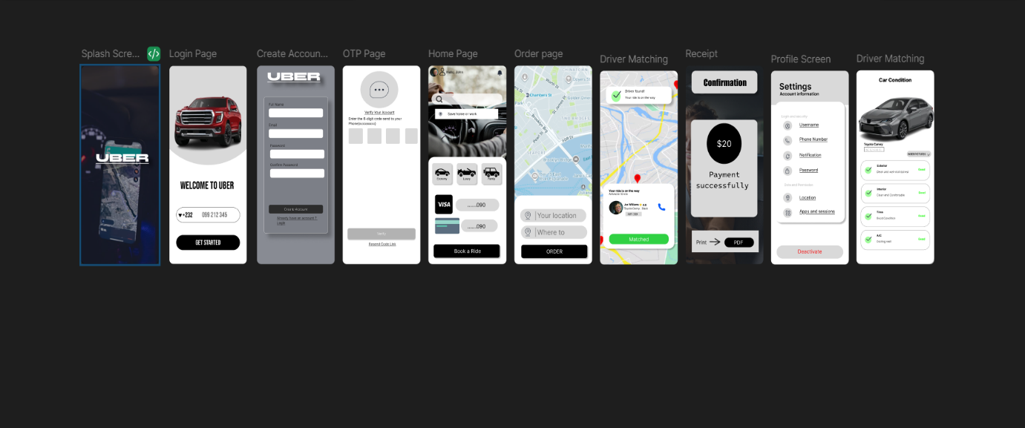

Our group built out a comprehensive high-fidelity prototype using Figma. We aimed for a highly clean, modern, and accessible visual look tailored to real-world users who need to navigate the app on the move. The list below breaks down the technical operations and architectural state-changes occurring inside each screen, arranged linearly from left to right:

1. Splash Screen
- Purpose: The entry point of the application; sets the brand identity and initializes essential background application services.
- Logic: User launches application, and the system checks for an active session token. If a valid session token is found, the system bypasses directly to Screen 5 (Home Page). If an expired token or no token is found, it routes the user to Screen 2 (Login Page).

2. Login Page
- Purpose: Allows registered passengers or system users to authenticate using their credentials.
- Logic: The user inputs their phone number/email and password, then clicks "GET STARTED". If authentication is a SUCCESS, the system routes them to Screen 5 (Home Page). If authentication FAILS, it returns an inline validation error message. For a new account request, clicking the register link routes them to Screen 3 (Create Account).

3. Create Account Page
- Purpose: Captures profile parameters to register a brand new user on the platform.
- Logic: The user inputs their Full Name, Email, Password, and Confirm Password, then clicks "Create Account". The backend registers the user in an "Unverified" state, and the system fires a 4-digit SMS OTP, auto-routing them to Screen 4 (OTP Page).

4. OTP Page
- Purpose: Two-factor authorization to verify phone number legitimacy and combat fraudulent profiles.
- Logic: The user enters the 4-digit code received via SMS and clicks "Verify". If the OTP MATCHES, the system updates the database status to "Active" and routes them to Screen 5 (Home Page). If the OTP MISMATCHES, it throws an "Invalid Code" error state. In the event of a TIMEOUT, the user can click the "Resend Code Link" to reset the timer and fire a new SMS.

5. Home Page
- Purpose: The primary operational dashboard containing live location tracking, quick vehicle profiling, and map discovery.
- Logic: The app pulls the client's GPS coordinates and renders the local map layer. The user selects their preferred Vehicle Type (Economy, Luxury, Family) and confirms their payment method (Visa card, Mobile Money wallet). Clicking the "Book a Ride" search bar routes them to Screen 6 (Order Page).

6. Order Page
- Purpose: Geolocation entry interface where the passenger sets their explicit route parameters.
- Logic: The system auto-populates the "Your Location" row via active GPS telemetry. The user types their destination into the "Where to" field, and the backend calculates the optimal path and fixed fare. Clicking the "ORDER" button initializes the driver-matching loop and routes them to Screen 7 (Driver Matching).

7. Driver Matching Screen
- Purpose: High-frequency backend polling phase that searches for localized drivers and updates the client on confirmation status.
- Logic: The system searches for the closest active driver within radial limits. While PENDING, it shows searching animations on the map state. Once a driver is FOUND, it pulls the driver's profile data (Name, rating, vehicle make/plate) and changes the UI state to "Matched". During trip execution, the driver collects the passenger and arrives at the destination, updating the trip status to "Completed" to route to Screen 8.

8. Receipt Screen
- Purpose: Post-trip transactional statement showing payment status and offering digital downloads.
- Logic: The system pulls finalized transaction metrics from the database and displays the total charge of $20. The user can click "Print" to send an output command to connected hardware, or click "PDF" to compile the transactional payload into an exportable asset. Dismissing the window routes the user back to Screen 5 (Home Page).

9. Profile Screen
- Purpose: Administrative account control matrix allowing data updates and app configuration tuning.
- Logic: The user selects the settings menu item to interact with account options like Username, Phone, and Password. If modifications are submitted, the system updates the user record table entries in the database. If the user clicks "Deactivate", it triggers a warning overlay, purges the active token, and routes them back to Screen 2.
10. CAR CONDITION
This screen allows users to view the current condition of their vehicle before or after a rental/trip. It displays a visual reference of the car along with an “Insert Pictures” option, letting users (or agents) upload photos documenting the vehicle’s state.

Below the image, the condition is broken down into categories, each marked with a green checkmark and a status label:

  - Exterior – Clean and well-maintained (Good)
  - Interior – Clean and comfortable (Good)
  - Tires – Good condition (Good)
  - A/C – Cooling well

This section is designed to build trust and transparency between the user and the service by providing a clear, itemized condition report, similar to a pre-rental or post-rental vehicle inspection checklist. It would logically sit after the user’s profile/account information in the app flow, since it relates to a specific vehicle tied to that user’s account or booking.

Conclusion

This report highlights our comprehensive design framework for a Smart Ride-Hailing System, a Digital Public Good deliberately built to address target goals within UN SDG 11. By grounding our project justifications in the concrete daily transportation issues faced across Sierra Leone, we engineered a scalable, layered system architecture built to withstand real-world operational challenges.
By mapping our development constraints via Gantt charts and project network topology, we identified our true Critical Path (A → C → D → E → F → H → J → K). This engineering road map ensures our team can successfully allocate development energy toward backend integrity and payment integrations, guaranteeing we meet our final launch objectives. Once fully deployed, this application will offer an impactful path toward transparent, safe, and reliable transit choices for our community.

